Input and output of code CTSTA

1 About the code
This code is for analyzing of the micro-structure of a parallelepiped. It can carry out the following calculations:
- volume fraction of the target phase (porosity);
- specific surface area of the target phase;
- percolation or connectivity;
- distribution of pore size or particle size in x, y and z directions;
- characteristics of each cluster (position, size, shape, orientation).

2 Input files
Two input files are necessary for this code to run.

2.1 Description file
One file is always “CTSTA.DAT”. It includes four lines or several groups of 4-line information when several datasets are prepared to be analysed. An example of 4-line information is like:
AllSlices.Binary
1 1300 1 1300 1 1550
20
1
- 1st line -- the images dataset file name – character
- 2nd line -- the description of the model-size you want to analyze – x0,xm,y0,ym,z0,zm (it could be the size of the dataset or a smaller part of the dataset, for example, 100 300 100 300 100 300 will only analyse a 200-cube volume in the model)
- 3rd line -- the interval of slices to be counted when calculating the distribution of fabric size (=1 will give a reliable result, if the dataset is extremely huge it could be >1)
- 4th line -- the truncation of “large cluster” (=1 means to analyze all clusters. Some times there are too many clusters and some small clusters are not important. We can ignore small clusters which have fewer voxels than this truncation value)

2.2 Data file
The other file is the image dataset with the extension ‘.bin1’. It is a binary format file with the structure of:
- max_x (number of voxels in x direction of the parallelepiped) in integer*4
- max_y (number of voxels in y direction of the parallelepiped) in integer*4
- max_z (number of voxels in z direction of the parallelepiped) in integer*4
- label data (with size of max_x*max_y*max_z) in integer*1

2.3 Creation of the data file
To create the data file, generally we need to:
- export a “binary” format label-data from Avizo®
- edit and run the python code “separate_am.py” (details in following)
- run Fortran code “readam” , it read both “.header” and “.binary” files and create the “.bin1” data file described in 2.2
Details about “separate_am.py”
1) Edit the label-data file names in “separate_am.py”, for example, there are 9 files with extension “.am” need to be processed, the array is defined as
files=['B3-to-byte-box1a','B3-to-byte-box1b','B3-to-byte-box1c',\
'B3-to-byte-box1d','B3-to-byte-box1e','B3-to-byte-box1f',\
'B3-to-byte-box3a','B3-to-byte-box3b','B3-to-byte-box3c']
2) Run code in “python separate_am.py” command and loaded module python in advance.
3) After the running, the original label-data is separated into two files: one is the “.header” ACSII format file and the other is “.binary” integer*1 binary format file.

3 Output files
There are 7 output files totally. Different output files need different post-processing tools.

3.1 General output file with extension “.out1”
It gives the basic information of the model and the analysed volume, including porosity, specific surface area, number of clusters, percolation and some calculation information.
An example:

THE SIZE OF THE MODEL B3-to-byte-cropped.shk03 IS:
1100 1093 964
THE VOLUME FOR PROBING IS: X = ( 1 , 1100 )
Y = ( 1 , 1093 )
Z = ( 1 , 964 )
TOTAL VOXELS OF THE VOLUME = 1159017200

Voxels of target fabric in this model is: 16963131
The volume percentage of the target fabric is: 1.4635789E-02

Surface of all target fabric: 29021258
The specific surface area (SSA) is: 2.5039541E-02

50% target fabric in clusters 1 to 1902 , their voxels >= 2125
60% target fabric in clusters 1 to 2842 , their voxels >= 1541
70% target fabric in clusters 1 to 4189 , their voxels >= 1034
80% target fabric in clusters 1 to 6333 , their voxels >= 597
90% target fabric in clusters 1 to 10937 , their voxels >= 212
95% target fabric in clusters 1 to 19246 , their voxels >= 45
99% target fabric in clusters 1 to 110005 , their voxels >= 2

Total number of clusters in this model is: 274344
The voxel-number for large cluster is truncated to: 1
Number of large clusters analysed (in .out2 & .out3) is: 274344

Percolation result in every direction:
(=0---nonpercolating, >0---number of percolating clusters )
X-direction: 0
Y-direction: 0
Z-direction: 5

Analysing all large clusters in groups of clusters ......
From cluster No. 1 to cluster No. 237
From cluster No. 238 to cluster No. 1686
From cluster No. 1687 to cluster No. 6003
From cluster No. 6004 to cluster No. 21435
From cluster No. 21436 to cluster No. 274344

FINISH THE CALCULATIONS !

3.2 Pore throat distribution file with extension “.ptd”
The distribution of pore throat is obtained on the basis of stereology by choosing arbitrary planes which parallel to x-, y- and z-axis. For a plane parallel to x-axis, for example, we counted the pores in different sizes in the x direction on the plane. After counting other planes parallel to x-axis, we obtained the counting summation of different apertures in the x-direction. In the counting in the y- and z-directions the operations are the same.
An example:

THE SIZE OF THE MODEL A02_pores IS:
1000 1500 400
THE VOLUME FOR PROBING IS: X = ( 1 , 1000 )
Y = ( 1 , 1500 )
Z = ( 1 , 400 )
THE DISTRIBUTION OF PORE THROAT IN THIS VOLUME :
PORE_THROAT X-DIRECTION Y-DIRECTION Z-DIRECTION
1 984655 1064286 2244827
2 879953 922393 875976
3 395757 402370 237347
4 156719 146109 88422
5 73034 64573 39058
6 37624 32800 19338
7 20446 17505 10268
8 11816 10206 5876
9 6938 5901 3531
10 4282 3667 2201
11 2775 2241 1391
12 1802 1486 958
13 1173 987 587
14 796 648 473
15 538 440 304
16 430 292 212
17 284 218 160
18 199 149 97
19 132 118 64
20 113 89 51
21 76 70 31
22 57 40 29
23 45 32 10
24 31 23 14
25 21 23 19
26 12 10 9
27 11 7 13
28 7 8 12
29 8 7 7
30 3 3 2
31 6 5 8
32 5 5 3
33 3 3 2
34 1 3 2
35 1 2 0
36 1 1 0
37 0 0 0
38 0 1 0
39 2 1 1
40 2 0 0
41 1 0 0
42 0 0 0
43 0 1 0

THE MAXIMAL APERTURES IN X-, Y- AND Z-DIRECTIONS ARE:
41 43 39

Excel is recommended to use to get charts. It is better to calculate the percentage of every pore-throat at first, and then draw curves of percentage, see the following figure.

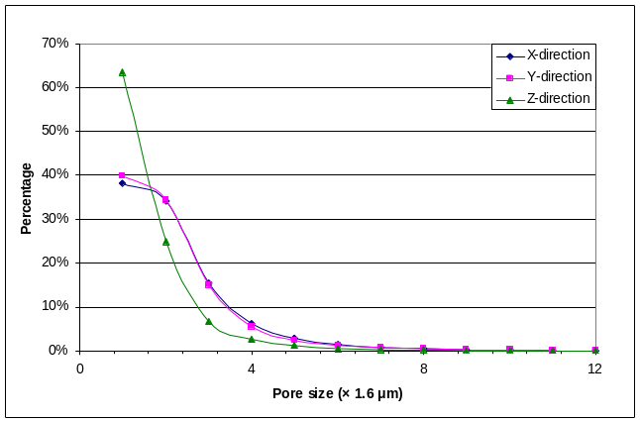

3.3 Percolating clusters with extension “.perc”
This output file is newly added for certsta5.f90 code. It gives the percolation result of the calculated volume and then lists all percolating clusters in the volume. The list simply gives the number of clusters, the percolation state (0 – non-percolating, 1 – percolating) in x, y and z direction, respectively.
An example:

Percolation result in every direction:
(=0---nonpercolating, >0---number of percolating clusters )
X-direction: 0
Y-direction: 0
Z-direction: 5

Percolating clusters include:
1 0 0 1
2 0 0 1
8 0 0 1
13 0 0 1
15 0 0 1

3.4 Cluster size file with extension “.clus”
This file records all clusters for their number, voxel size, squared radius, accumulated target fabric size and accumulated percentage. The squared radius is very useful for analysis of correlation length, mean cluster size and fractal dimension.
An example:

5911
NO. SIZE RS^2 ACCUPORE PERCENT
1 68975 3844.05 68975 0.05600
2 65934 3765.25 134909 0.10953
3 65904 3351.26 200813 0.16303
4 63667 3458.82 264480 0.21472
5 42152 3236.16 306632 0.24894
6 39324 2601.34 345956 0.28086
7 38405 3376.78 384361 0.31204
8 35706 3531.85 420067 0.34103
9 31672 3732.16 451739 0.36674
10 27407 3022.34 479146 0.38899
11 26740 3433.68 505886 0.41070
12 26116 3284.45 532002 0.43191
13 25164 3089.31 557166 0.45234
14 24855 1951.28 582021 0.47251
15 24777 3502.75 606798 0.49263
16 22988 2969.56 629786 0.51129
17 20890 3385.64 650676 0.52825
18 18324 3778.10 669000 0.54313
19 17728 3399.38 686728 0.55752
20 17715 3550.37 704443 0.57190
…
…
…
5900 1 0.00 1231744 0.99999
5901 1 0.00 1231745 0.99999
5902 1 0.00 1231746 0.99999
5903 1 0.00 1231747 0.99999
5904 1 0.00 1231748 0.99999
5905 1 0.00 1231749 1.00000
5906 1 0.00 1231750 1.00000
5907 1 0.00 1231751 1.00000
5908 1 0.00 1231752 1.00000
5909 1 0.00 1231753 1.00000
5910 1 0.00 1231754 1.00000
5911 1 0.00 1231755 1.00000

Post-processing
Code “sta_clus.f90” reads this “.clus” file and outputs a “.cnss” file, which gives the averaged radius of clusters with the same voxels number, and fraction of different clusters.
Code “clusize.f90” reads the “.cnss” file and outputs a “.mscl” file which gives mean cluster size and correlation length, including the results with the largest cluster and without the largest cluster.
Combined with the percolation result, “.mscl” gives the right results of mean cluster size and correlation length. However, these calculations of mean cluster size and correlation length are based on the assumption of percolation theory that only one percolating cluster exists in a lattice model. For some special models, this assumption is not always correct, i.e., tree branches have lots of percolating vessels in the growing direction.

3.5 Cluster shape file with extension of “.out2”
This file records the size (voxels), surface, eigenvalues, isotropy index, and elongation index of all clusters in the calculated volume.
An example:

1 200 1 200 1 200
Cluster Voxels Surface EignV-1 EignV-2 EignV-3 Iso-index Elong-index
1 40768 33172 0.7834E+06 0.1273E+07 0.1389E+09 0.006 0.991
2 32523 40213 0.1668E+06 0.8178E+07 0.1087E+09 0.002 0.925
3 27073 16336 0.4443E+06 0.6526E+06 0.4367E+08 0.010 0.985
4 26011 17659 0.3463E+06 0.4495E+06 0.9452E+08 0.004 0.995
5 24812 16004 0.4875E+06 0.7300E+06 0.2439E+08 0.020 0.970
6 22320 12463 0.2063E+06 0.2652E+06 0.7272E+08 0.003 0.996
7 19651 12129 0.1661E+06 0.2088E+06 0.6309E+08 0.003 0.997
8 19434 12316 0.1400E+06 0.3102E+06 0.6372E+08 0.002 0.995
9 17685 11278 0.1268E+06 0.2050E+06 0.6033E+08 0.002 0.997
10 16478 11183 0.1486E+06 0.1750E+06 0.5157E+08 0.003 0.997
11 16200 8521 0.1403E+06 0.2457E+06 0.2312E+08 0.006 0.989
12 15718 8953 0.1587E+06 0.1881E+06 0.2143E+08 0.007 0.991
13 14638 13912 0.8294E+05 0.9084E+06 0.5018E+08 0.002 0.982
14 14278 14432 0.1308E+06 0.2536E+06 0.4591E+08 0.003 0.994
15 13694 20345 0.5810E+05 0.1988E+07 0.4970E+08 0.001 0.960
16 13673 11525 0.7610E+05 0.2447E+06 0.4690E+08 0.002 0.995
17 13243 8982 0.5543E+05 0.2032E+06 0.3933E+08 0.001 0.995
18 13226 8181 0.1593E+06 0.1600E+06 0.1235E+08 0.013 0.987
19 13213 12193 0.1633E+06 0.8792E+06 0.9413E+07 0.017 0.907
20 13145 7577 0.7248E+05 0.1680E+06 0.3120E+08 0.002 0.995
…
…
…
6221 1 6 0.5000E+00 0.5000E+00 0.5000E+00 1.000 0.000
6222 1 6 0.5000E+00 0.5000E+00 0.5000E+00 1.000 0.000
6223 1 5 0.5000E+00 0.5000E+00 0.5000E+00 1.000 0.000
6224 1 6 0.5000E+00 0.5000E+00 0.5000E+00 1.000 0.000
6225 1 6 0.5000E+00 0.5000E+00 0.5000E+00 1.000 0.000
6226 1 6 0.5000E+00 0.5000E+00 0.5000E+00 1.000 0.000
6227 1 6 0.5000E+00 0.5000E+00 0.5000E+00 1.000 0.000
6228 1 6 0.5000E+00 0.5000E+00 0.5000E+00 1.000 0.000
6229 1 6 0.5000E+00 0.5000E+00 0.5000E+00 1.000 0.000
6230 1 6 0.5000E+00 0.5000E+00 0.5000E+00 1.000 0.000
6231 1 6 0.5000E+00 0.5000E+00 0.5000E+00 1.000 0.000
6232 1 6 0.5000E+00 0.5000E+00 0.5000E+00 1.000 0.000
6233 1 6 0.5000E+00 0.5000E+00 0.5000E+00 1.000 0.000

Post-processing
For this output file, voxels and surface can be used in some detailed analysis. Three eigenvalues can be represented by isotropy index and elongation index. These two indexes can be statistically analysed using Excel. However, using “R” statistics package is much more convenient and efficient. Here are procedures of operation:
- The first line of the file leads error of reading in “R”. It is necessary to delete the first line and save it before further operation.
- Start “R”.
- Load data file and assign values to a matrix, say “x”, by using command:
x<-read.table("C:/TensorVis/B3_small.out2",header=TRUE, row.names=1).
Note the expression of path is different from computer to computer. Run the command “getwd()” first and check the slash should be forward or backward, or double slashes.
- Assign values in 7th column to an array, say “iso”, by using command:
iso <- x[,6].
Note, the isotropy index is in the 7th column of the file, but the reading takes the first column as number of rows, so 7th column of original data becomes 6th column of the matrix.
- Assign values of elements from 1 to 1000 (or whatever we want to select) of array “iso” to a new array, say “iso1000”, by using command:
iso1000 <- iso[1:1000].
- Draw histogram of “iso1000” by using command:
hist(iso1000).

The histogram of isotropy index is like the following figure:

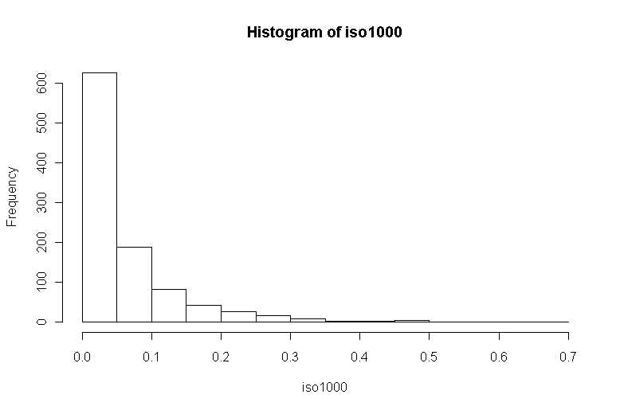

To have histogram of elongation, we only need to assign value of x[,7] to an array and run the similar procedures.

3.6 Cluster orientation matrix file with extension of “.out3”
This file records the central coordinates and 9 components of orientation matrix of every cluster. An example of the file is like:

1 200 1 200 1 200
1 145.1119 17.80887 101.0056
0.284E+07 -0.144E+07 -0.154E+08
-0.144E+07 0.180E+07 0.105E+08
-0.154E+08 0.105E+08 0.136E+09
2 91.30799 43.16791 102.2745
0.620E+07 -0.349E+07 -0.227E+07
-0.349E+07 0.219E+07 0.318E+06
-0.227E+07 0.318E+06 0.109E+09
3 85.90939 186.1673 68.77025
0.710E+06 0.240E+04 -0.314E+07
0.240E+04 0.645E+06 -0.111E+07
-0.314E+07 -0.111E+07 0.434E+08
4 72.69766 70.36938 100.4560
0.438E+06 0.682E+05 -0.272E+07
0.682E+05 0.568E+06 -0.351E+07
-0.272E+07 -0.351E+07 0.943E+08
5 167.5371 58.68322 146.0404
0.694E+06 -0.828E+05 0.159E+06
-0.828E+05 0.540E+06 0.614E+06
0.159E+06 0.614E+06 0.244E+08
……

“Mayavi2” software package is selected to visualize the orientation matrix of clusters. Important documentation in:
http://code.enthought.com/projects/mayavi/docs/development/html/mayavi/installation.html#installing-ready-made-distributions
Under Window the best way to install Mayavi is to install a full Python distribution, such as EPD or Pythonxy.
I would recommend Pythonxy, then click “Download” in left side and select “xyweb-1.0.3”. Need to check in ‘ETS’ in the installer, when selecting components.
A post-processing code “tsvtu.f90” is designed to read data, select clusters, and write suitable format file for Mayavi2. For better visualization, we need to calculate a scale of mapping all clusters’ sizes to be displayed in Mayavi2 properly. Code “tsvtu.f90” calculates this scale by using eigenvalues of clusters, so file “.out2” are also necessary to be read.
Operations of running “tsvtu”:
- Double click the executable file tsvtu.exe.
- Input the file name without extension .out3 from keyboard.
- Input the range of cluster that we want to see, for example, “Beginning cluster number” 10 and “Ending cluster number” 50, means we select clusters 1 to 50 to visualize in Mayavi2 (only 10 and 50 are input from key board).
After the running, a new file with the input file name plus “TS.vtu” is created.
Mayavi2 is a powerful and complicated software, basic operations for tensor visualization are:
- Load data from file
- Select menu “Visualize” – “Modules” – “TensorGlyph”
- Increase the “scale factor” in “Tensor Glyph” – “Glyph” panel if glyphs are invisible
- Select preferred glyph source in “Tensor glyph” – “Glyph Source” penal and increase “phi resolution” and “theta resolution” in for smoother glyphs
- Choose color in “Actor” panel.
Here is an example of tensors represented by spheres of a tree branch sample showing 50 largest clusters.

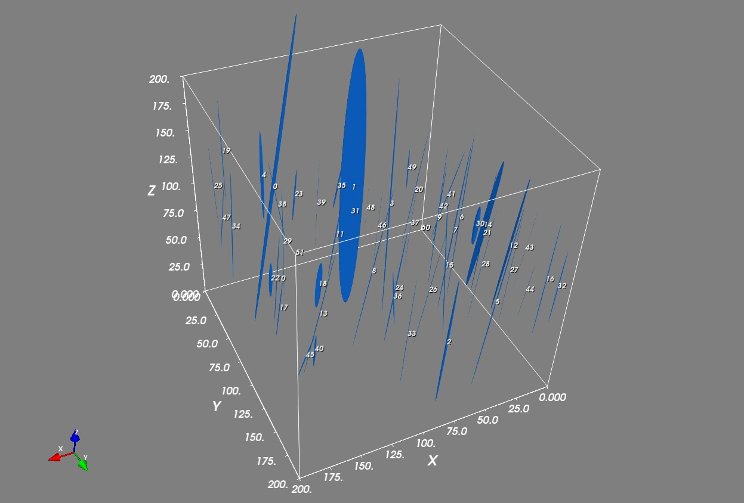

3.7 Normalized cluster orientation matrix file with extension of “.out4”
File ‘.out4’ includes normalized orientation matrix of clusters and their direction cosine of every eigenvectors. The structure of the file is like:

1 200 1 200 1 200 (/sample dimensions)
1
0.634 -0.765 -0.113 50.6 139.9 96.5
0.773 0.630 0.077 39.4 51.0 85.6
0.012 -0.136 0.991 89.3 97.8 7.9
2
0.502 -0.864 -0.022 59.8 149.8 91.3
0.865 0.502 0.004 30.2 59.8 89.8
0.008 -0.021 1.000 89.5 91.2 1.3
3
0.906 0.416 -0.073 25.0 65.4 94.2
0.415 -0.909 -0.026 65.5 155.4 91.5
0.077 0.007 0.997 85.6 89.6 4.4
4
0.937 -0.347 -0.029 20.4 110.3 91.7
0.346 0.937 -0.037 69.7 20.4 92.1
0.040 0.025 0.999 87.7 88.6 2.7
5
0.389 0.921 0.007 67.1 22.9 89.6
0.921 -0.389 0.026 22.9 112.9 88.5
-0.026 0.004 1.000 91.5 89.8 1.5
…
…
…
2156
0.898 -0.388 -0.206 26.1 112.8 101.9
0.426 0.884 0.194 64.8 27.9 78.8
0.107 -0.262 0.959 83.9 105.2 16.4
2157
0.983 -0.181 0.016 10.5 100.4 89.1
0.176 0.971 0.159 79.8 13.7 80.8
-0.044 -0.154 0.987 92.5 98.8 9.2
2158
0.605 0.447 0.659 52.7 63.4 48.8
-0.768 0.547 0.334 140.1 56.8 70.5
-0.211 -0.708 0.674 102.2 135.0 47.6
2159
-0.809 0.587 -0.036 144.0 54.0 92.1
0.581 0.807 0.108 54.5 36.2 83.8
-0.092 -0.066 0.994 95.3 93.8 6.5
2160
0.816 0.408 -0.408 35.3 65.9 114.1
0.408 -0.908 -0.092 65.9 155.3 95.3
0.408 0.092 0.908 65.9 84.7 24.7

Post-processing
A post-processing code “stereoseg.f90” has been designed to read this dataset and to export files for stereo-net projection using “StereoWin” software package.
Operations of running “stereoseg”:
- Double click the executable file stereoseg.exe.
- Input the file name without extension .out4 from keyboard.
- Input the range of cluster that we want to see, for example, “Begin from No. ” 1 and “End to No.” 2000, means we select clusters 1 to 2000 to analyse the distribution of their orientation (only 1 and 2000 are input from key board).
After the running, three files are created, with the file name beginning with 8 characters of input file name plus EV1, EV2, and EV3 respectively, and the extension of these three files is “.txt”.
Operations of using “StereoWin”
- Double click the executable file “StereoWin 1.2.exe”
- Open file, for example, “B3_croppEV1.TXT”, use default settings and click OK.
- Select menu “Plot” and “Scatter” to visualize the distribution of the orientations.
Here is an example of the distributions in the stereo-net:
